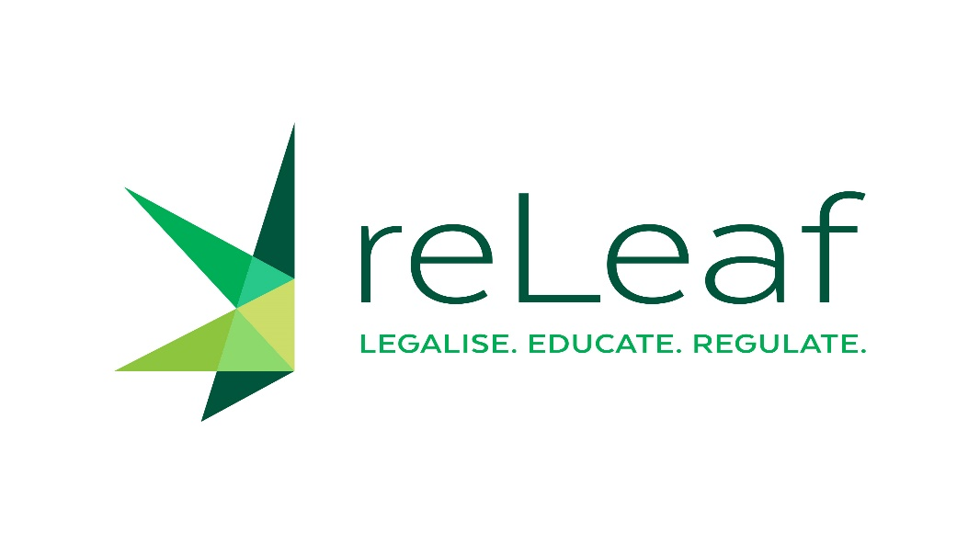

Joint Social and Family Affairs Committee meeting,
Wednesday 26 May 2021,
House of Representatives


Costanza Sánches Avilés

Constanza Sánchez Avilés is the Law, Policy & Human Rights Director at the International Center for Ethnobotanical Education, Research & Service (ICEERS). She is a political scientist and holds a PhD in International Law and International Relations. Her main areas of work are national and international drug control policies and the intersection between drug control, human rights and social justice. From 2007 to 2013 she was lecturer and researcher at the Universitat Pompeu Fabra (Barcelona). She has been visiting scholar at the University of Miami (2010), the University of San Diego (2012) and research assistant at the Global Drug Policy Observatory, UK (2013). She has also conducted fieldwork in Europe, Peru, the United States, Colombia, Mexico and the US-Mexican border. Constanza regularly participates at the sessions of the UN Commission on Narcotic Drugs and the Human Rights bodies in Geneva, as well as other international meetings as CSO representative. She collaborates with several drug policy institutions and assiduously publishes and lectures on her areas of research.


Fabian Pitter Steinmetz

Dr. Fabian Pitter Steinmetz studied process engineering at the Umwelt-Campus Birkenfeld (Germany) and toxicology at the Athlone Institute of Technology (Ireland). After gaining experience in the biopharmaceutical industry, he obtained a PhD in predictive toxicology from Liverpool John Moores University (UK).
He works at the international consultancy Delphic HSE Ltd since early 2016, interrupted by a post-doc at Merck KGaA in the area of drug design.
Until now Steinmetz has authored/co-authored over 200 safety assessments, expert opinions and scientific publications. Also, he is a European Registered Toxicologist (ERT) since early 2020 and he supports an evidence-based drug policy reform as a committee member of the independent German expert panel „Schildower Kreis

